THE INVESTMENT ANALYSTS JOURNAL

M Ward*

The CAPM in an options pricing framework
∗ Wits Business School, University of the Witwatersrand, PO Box 98, Wits 2050, Republic of South Africa.
Email: ward.m@wbs.wits.ac.za

1. INTRODUCTION
The CAPM of Sharpe (1964), Lintner (1965) and Markowitz (1952) provides a parsimonious framework for understanding the risk-return relationship between securities. It has received (and largely survived) extensive criticism, but despite the theoretical elegance and pedagogic simplicity, it does not satisfy the day to day realities of fund managers. There are possibly several reasons for this, but two in particular are examined in this paper; the definition of risk and the expectations framework of the CAPM.
The CAPM provides an “expectations” framework for security returns. The model estimates expected portfolio (and security) returns on the basis of the risk-free rate, the expected market premium and the expected level of systematic risk i.e. beta. Whilst this is reasonable, the parameters are variables over time, not constants, and the focus on the expected return takes insufficient account of the spread of returns – especially for shorter review periods. Several researchers (e.g. Levy, 1984) have examined the relationship between risk, return and the investment review period. There is considerable debate between practitioners and academics as to whether a longer investment horizon reduces risk (e.g. Butler and Domian (1991) and Bodie, Kane and Marcus (1996)). However, practice suggests that fund managers believe in time diversification, and that they are able to “beat the market” by utilising short term tactics of active portfolio management through asset selection and market timing. Indeed, Jeffery (1984), Sandler (1989) and others have shown that the returns achievable through market timing are dramatically increased (or decreased if accuracy levels are low!) through short review periods. This is particularly true if derivatives are used to effect the switching of assets on account of the considerably reduced transaction costs (Waksman, Sandler, Ward and Firer (1997)). So, whilst the CAPM lends itself to a long term perspective, practice is the opposite.
Furthermore, the CAPM defines risk as “systematic”, following Markowitz’ (1952) diversification argument. This is perhaps insufficient, as the parameter used to measure systematic risk , beta, does not fully reflect investors’ understanding of risk. Specifically, whilst beta excludes non-systematic risk, it makes no distinction between downside risk (loss) and upside potential (profit). Although it is generally accepted that security returns are symmetrical, the incorporation of option strategies into portfolio management radically changes the shape of the expected return distribution. This paper examines the following proposition: Risk is asymmetric. Investors care about losing, and this is what they mean by “risk”. They are not concerned about possible upside potential - just downside loss.
The paper presents some thoughts on using option theory in an attempt to deal with these issues.

2. THE RISK-RETURN PERSPECTIVE
The expected market premium is defined as the expected excess return over the risk-free rate for bearing systematic risk in the market. This is calculated by averaging the excess annual returns generated from the market over the risk-free rate:
Expected Market Premium = 1/n Σ(Rm - Rf) …(1)
where: Rm = annual return on the market portfolio
Rf = annual return on the risk free asset
n = the number of years in the sample
Whilst this may be an acceptable approach in the long-term expected framework of the CAPM, it fails to capture the short-term dynamics of the market. Figure 1 shows a sample of the time-series of the monthly market premium on the JSE.
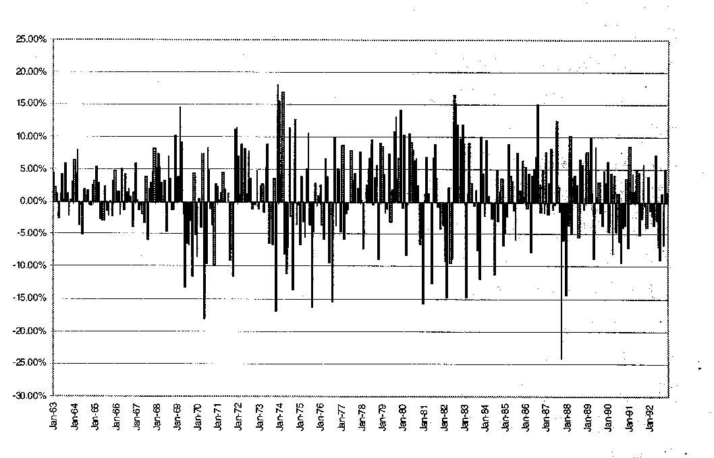
Figure 1: Time-series of the monthly market premium on the JSE

As can be seen from Figure 1, there is considerable short-term variation in the market premium. Active fund managers, confronted with the knowledge that fixed interest securities out-perform equities on occasion, are tempted to engage in market timing activities. Certainly, if one accepts that the slope of the Securities Market Line (SML) is not constant but changes dynamically in the short term, one is drawn to the conclusion that investor’s indifference curves will intersect tangentially at different points along the SML for short review periods, implying that fund managers should engage in market timing. Figure 2 presents the SML from a dynamic perspective:
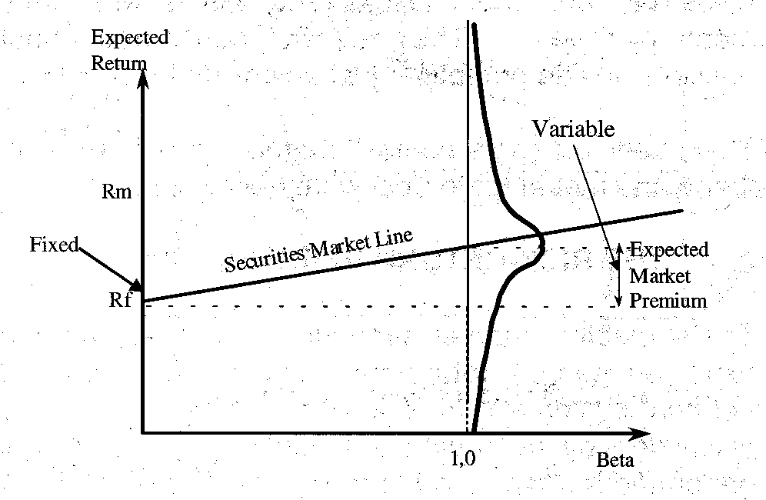

Figure 2: A dynamic representation of the SML

The use of a constant for the market premium in a short-term asset pricing model is therefore over-simplistic. Both the risk-free asset and the market portfolio follow a distribution of returns and theoretically these are likely to be negatively correlated.

As can be seen from Figure 2, the slope of the SML follows a distribution for short review periods. In fact, if we assume a fixed risk-free rate, almost 50% of share returns will be below Rf if the portfolio contains any proportion of the Market. This is the simple consequence of a symmetrical distribution of returns. In some instances the SML will slope downwards, and the optimal portfolio is cash, and at other times it will be steeply upward sloping, suggesting a greater portfolio allocation into the market. To the extent then, that fund managers are able to correctly time the market, they should be encouraged to do so.

Most researchers advocate the use of a long term Government bond as a proxy for the risk free rate. Several reasons can be given for this. Firstly, many investment decisions (e.g. company valuations) have a long-term perspective – it therefore makes sense to use a long-term proxy. Secondly, re-investment risk is avoided with a long-dated asset. Thirdly, the long end of the yield curve is affected primarily by market sentiment – this cannot be said for the short end, which is frequently manipulated by central bankers as an economic lever. However, in South Africa, the so-called “Prescribed Assets” ruling which was in effect in the 1970’s and 1980’s, created an inefficient market in long-term RSA bonds. This has created difficulties in estimating the correct expected market premium and encouraged the use of a short term risk free proxy (see Firer, 1993).

Whilst there are many arguments upholding the use of a long term risk free proxy, a crucial consideration is the investment horizon. It is only possible to achieve a “risk free” return if the investment horizon matches the duration of the risk free asset. If these are miss-aligned, significant re-investment risk is introduced. From a market timing perspective therefore, the use of a short term proxy⁴, appropriately matched to the review period, ensures the risk free rate is in fact a constant – as illustrated in Figure 2.

²See later discussion on the distribution of the risk free return.
³Conventional macro-economic policy requires central banks to lower their (short-term) lending rates when the yield curve is high to stimulate the economy and vice-versa to slow down growth when long-term rates are low. Consequently, the expected market premium would be high as short-term interest rates are reduced in anticipation of an expansionary market and vice-versa.
⁴E.g. a 90 day T-Bill or an interest rate swap.

3. MEASURING RISK
As indicated earlier, the CAPM defines risk in a symmetrical fashion. An investor who introduces a proportion of the market asset into what was previously a pure cash, risk free portfolio, simultaneously introduces systematic risk. The portfolio’s expected return is proportionally higher, but subject to a (symmetrical) distribution of possible returns. Contrast this scenario with an investor who uses a portion of the original cash to purchase a call option on the market⁵. Whilst the expected portfolio return can be shown to be higher than the risk free rate and equal (say) to the coventional portfolio, the distribution of returns is not symmetrical and the expected downside risk is limited. Table 1 illustrates the concept.

Table 1 shows four alternative investment scenarios. The first is simply a 100% investment into the risk free asset (Rf) guaranteeing an annualised return of 10%. The second is a conventional portfolio consisting of 50% Rf and 50% the market asset (Rm). The third scenario consists of 97,3% Rf and 2,7%⁶ invested in a one month call option on the market with an exercise price equal to spot. Finally, the fourth scenario consists of a portfolio of 98,1% the market and 1,9% into a 1 month at-the-money put option.

Table 1: Investment scenarios
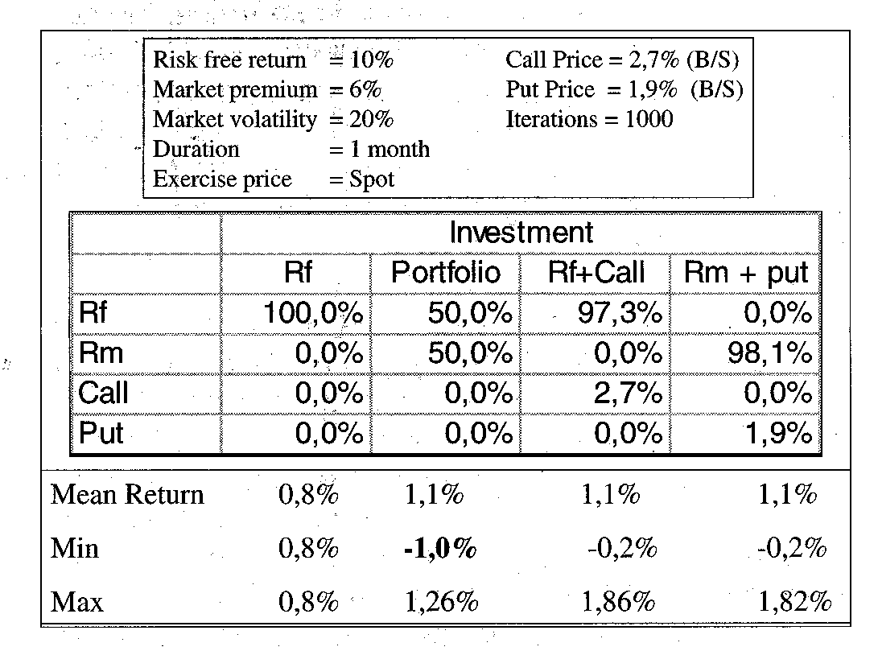
A Monte Carlo simulation was conducted to compare the risk/return distributions of the four scenarios. The future market level (and hence return) was simulated over 1 000 iterations, using the function⁷ suggested by Winston (1996:143). The results are shown in Table 1 and Figure 3.
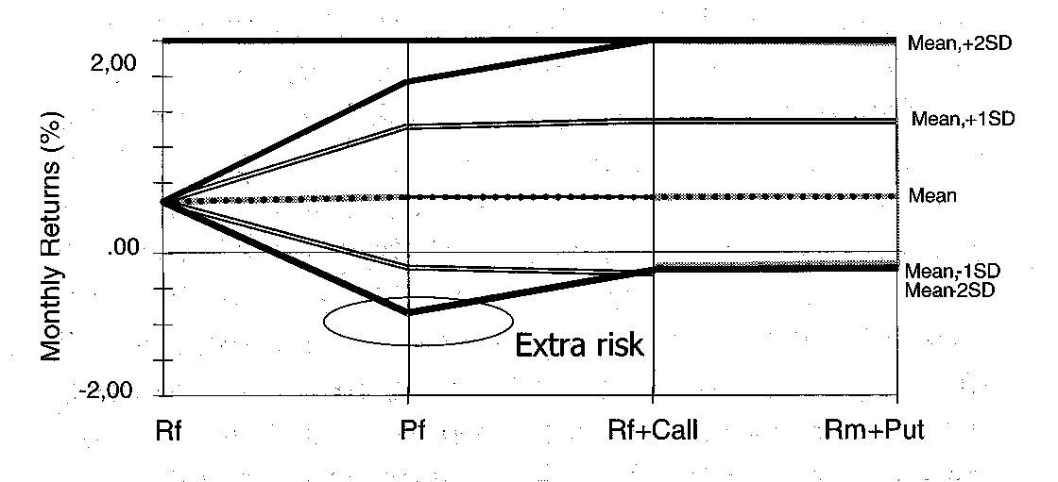

Figure 3: Results from Monte Carlo simulation

Figure 3 and Table 1 show that whilst the expected return is similar for scenarios 2, 3 and 4, the potential minimum return (risk) is greater for scenario 2. Investors might prefer the latter two derivative based portfolios which limit downside risk; but a better definition of downside risk is required before we can come to this conclusion.
The incorporation of derivative products into portfolios suggests that the use of a symmetrical measure of risk such as beta is inappropriate. “Practitioners typically think of risk in terms of the probability and severity of losses, shortfalls or under-performance with respect to a benchmark or goal” (Merrill and Thorley, 1996:13). Following this thought, risk could be more appropriately defined as the probability of under-performing a benchmark, the most obvious being the risk free rate – as illustrated in Figure 4 below:
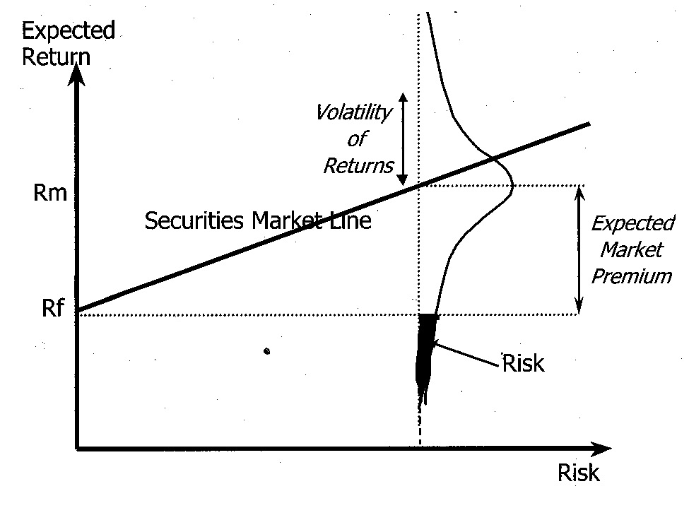

Figure 4: Defining downside risk
Figure 4 illustrates the concept of defining risk in relation to the probability of achieving a return below the risk free rate⁸. Regrettably, it is insufficient to measure risk purely as the probability of attaining returns below Rf, as the shape of the probability distribution will be complex if derivatives are used. The expected value (i.e. “centre of gravity”) of the returns below Rf is required. Risk can then be defined as the expected downside return. So, for a particular investment strategy there may be a 30% probability that the return will be below Rf . If the average downside return is 3%, then the level of risk can be defined as being 7% if Rf is 10% (ie the distance below Rf). The expected downside return is then 30% * 7% = 2,1%. For the purpose of discussion the term bet⁹is used hereafter to refer to the expected downside risk.
From Figure 4 it can be observed that there are two parameters which influence bet: the expected market premium and the volatility of returns. Whilst the CAPM incorporates both of these, the latter encapsulated in the beta parameter, bet is a more explicit definition of risk as it focuses only on the downside return and can be measured regardless of the shape of the distribution of returns.
Table 2 below shows the relationship between the frequency of returns below Rf, the volatility of returns and the market premium. Table 2 also shows the average value of the downside returns (i.e. the average of the returns below Rf), and hence bet, for combinations of volatility and market premium.

Table 2: Risk, volatility and the market premium
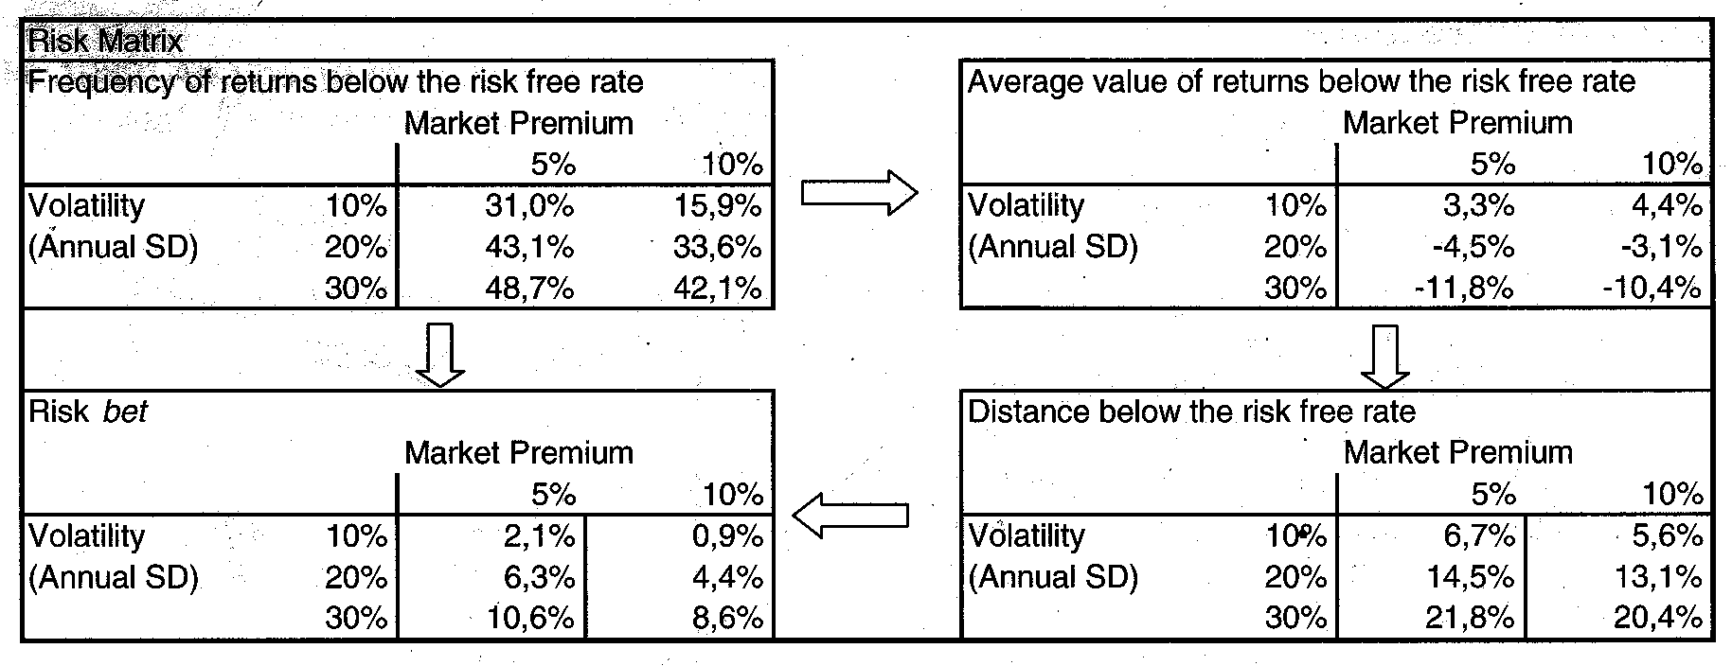
Table 2 was calculated by simulating the returns (again using Winston’s (1996) formulation to model the distribution of Rm) and measuring the frequency of returns below Rf for different combinations of volatility and different levels of the market premium. The level of risk (bet) is then calculated as the expected downside return below Rf, and shown for each combination of volatility and market premium. To illustrate, 48,7% of returns would be below Rf if the annual standard deviation of market returns was 30% and the market premium 5%. The average value of the downside returns (only) would be
–11,8% and, for Rf=10% the distance below Rf would be 21,8%. The expected downside risk (i.e. bet) = 48,7%*21,8%=10,6%.
It is interesting to note that for short review periods, say monthly, whilst the expected return decreases linearly by a factor of 1/12, the standard deviation decreases by a factor of only 1/[sqrt(12)]. There is proportionally greater volatility for shorter review periods, which, from a market timing perspective, is attractive.
For a given market premium and volatility, the level of portfolio risk can be increased by the following strategies:
- Increasingly moving assets from Rf into Rm. This is the conventional approach which, after 100% of the assets are at Rm, requires borrowing at Rf and re-investing the borrowed funds into Rm.
- Increasingly writing options, either by increasing the number of options or by increasing their moneyness. This assumes the investor writes options to earn the premium, but, in doing so, assumes more downside risk.
- Increasingly moving assets from Rf into call options on the market. This can be done by increasing the number of call options or by increasing the moneyness of the call options.
- Variations on the above.

For example, an investor who is long the market may limit downside risk by purchasing put options; “portfolio insurance”. The expected portfolio return will decrease because of the cost of the option, but the downside risk distribution has a floor. Alternatively, by writing covered call options, a premium is earned, but the distribution of possible returns is capped and the result more (downside) risky.

We now turn our attention to the risk/return relationship.

Once again, a Monte Carlo simulation was used to compare the risk/return relationship of various portfolios. Variations on four portfolios are shown in Table 3:

Table 3: Portfolio composition
Portfolio | Return
Rm + Rf | A conventional portfolio with weightings of Rf and Rm.
Rf + C | A call option on the market plus the risk free return for the surplus.
Rm + P | A put option on the market plus the market return for the surplus.
Rm – P | The market return for the initial capital plus put option premium, less any losses on writing the put.
For each portfolio, three variations of moneyness were examined. Prices for the options were calculated for at-the-money European options and with the strike plus/minus 10% the spot. The risk free rate was fixed at 10% pa, the market premium at 5%, the volatility of the market at 20% and the term at 1 month. Table 4 presents the results.

Table 4: Monthly risk/return results
 |  | Average | Risk | Risk | % Under | Expected | Risk
 |  | Return | Std | Beta | Rf | Downside | Bet
 |  | (Monthly) | Devn |  |  | Risk
Conventional | Market | 1,4% | 5,9% | 1,00 | 47,5% | 4,3% | 2,1%
 | Rf25M75 | 1,2% | 4,4% | 0,75 | 47,5% | 3,2% | 1,5%
 | Rf50M50 | 1,1% | 2,9% | 0,50 | 47,5% | 2,2% | 1,0%
 | Rf75M25 | 0,9% | 1,5% | 0,25 | 47,5% | 1,1% | 0,5%
Calls | RfC+10 | 0,8% | 1,0% | 0,09 | 93,0% | 0,2% | 0,2%
 | RfCATM | 1,1% | 4,0% | 0,62 | 60,0% | 2,3% | 1,4%
 | RfC-10 | 1,3% | 5,8% | 0,99 | 48,0% | 4,3% | 2,1%
Puts | RmP-10 | 1,3% | 5,8% | 0,99 | 48,0% | 4,3% | 2,1%
 | RmPATM | 1,1% | 3,9% | 0,60 | 60,5% | 2,2% | 1,3%
 | RmP+10 | 0,8% | 0,9% | -0,01 | 57,0% | 0,4% | 0,2%
Written Puts | Rm-P-10 | 1,4% | 5,9% | 1,01 | 47,0% | 4,4% | 2,1%
 | Rm-ATM | 1,6% | 8,4% | 1,40 | 38,0% | 7,9% | 3,0%
 | Rm-P+10 | 1,9% | 11,8% | 2,01 | 47,0% | 9,0% | 4,2%
Table 4 reflects a positive relationship between average return and risk. The average return from the market was 1,4% with σ =5,9%. 47,5% of the portfolio returns were below Rf, the expected downside return was 4,3% below Rf and bet = 2,1%. Rf25M75 represents the conventional portfolio with 25% weighting in Rf and 75% in Rm. The risk/return relationship is linear for risk measured conventionally with beta and when measured with bet. Both the at-the-money call strategy (RfCATM) and the at-the-money covered put strategy (RmPATM) show the same expected return as the Rf50M50 conventional portfolio (1,1%), but all the risk metrics are higher for the option strategies. Unsurprisingly, the in-the-money call strategy (RfC-10) and the out-the-money put strategy (RmP-10) show results which (essentially) mirror the market portfolio. The risk/return results are generally best for the conventional portfolios. Figure 5 shows that the relationship to downside risk is essentially linear for all strategies.
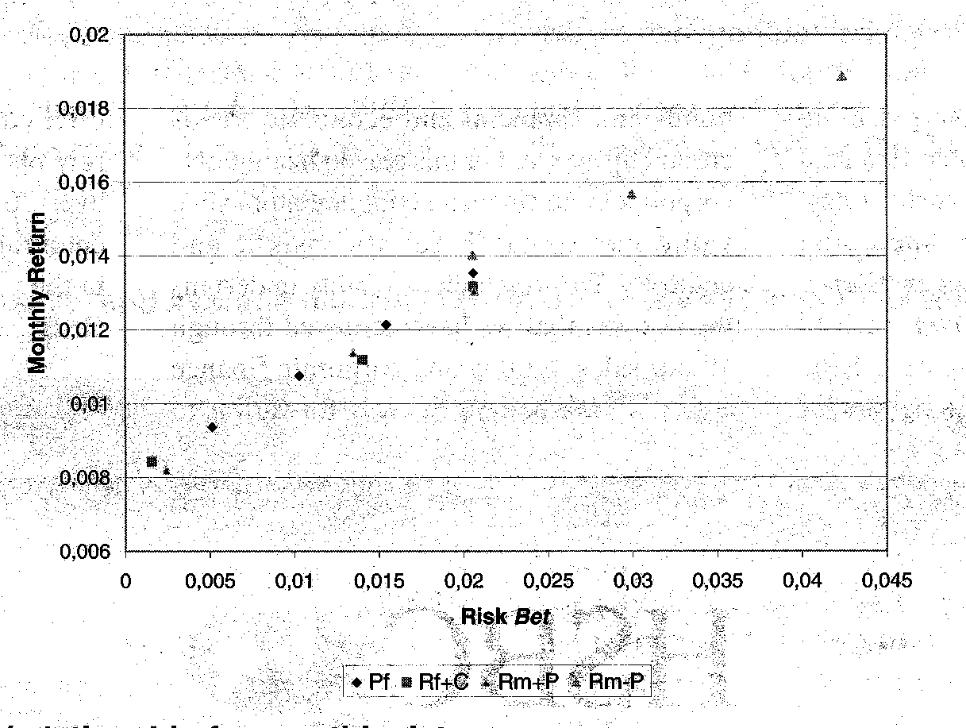

Figure 5: The risk return/relationship for monthly data
Figure 5 shows that the options based strategies produce identical results to conventional portfolios when risk is measured as defined earlier. Higher returns can be attained for greater downside risk, in a linear fashion, by purchasing calls, purchasing puts or writing options.
A further simulation was conducted to explore the relationship between various levels of moneyness for an investor holding Rf and purchasing call options. The resulting risk/return relationship is shown in Table 5 and Figure 6:

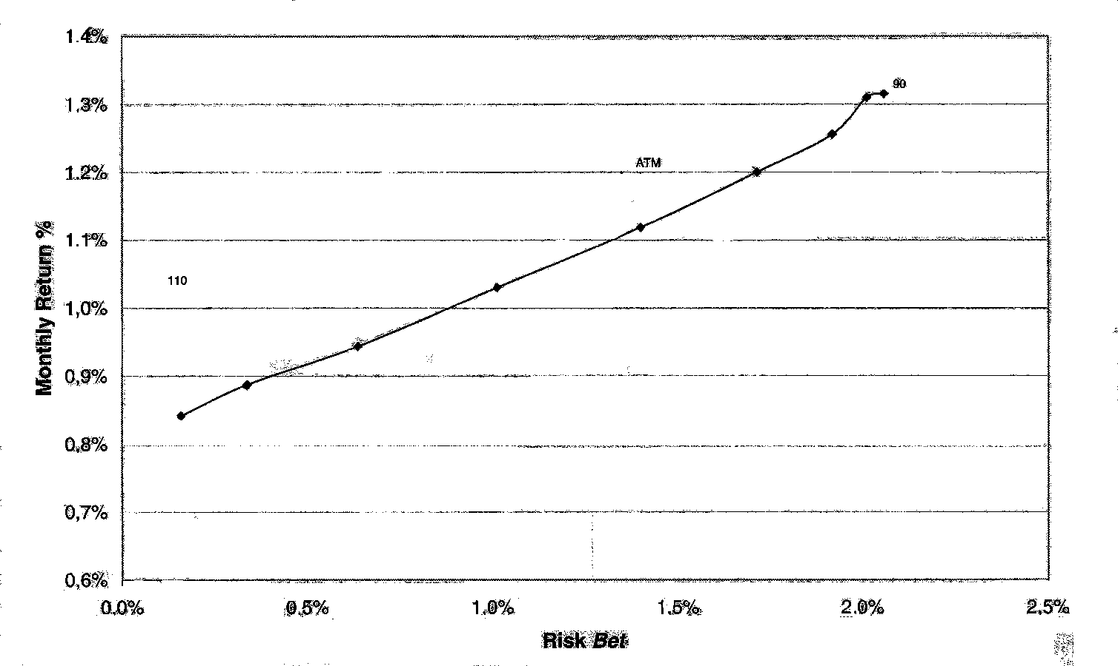

Figure 6: Risk/return graph for a call option portfolio of different strike prices

Table 5: Monthly risk/return data for call options of different strike prices
Strike | 90,0 | 92,5 | 95,0 | 97,5 | 100,0 | 102,5 | 105,0 | 107,5 | 110,0
Option Cost | 10,78% | 8,40% | 6,21% | 4,27% | 2,71% | 1,57% | 0,83% | 0,39% | 0,17%
Average Return | 1,3% | 1,3% | 1,3% | 1,2% | 1,1% | 1,0% | 0,9% | 0,9% | 0,8%
Std Dev | 5,8% | 5,6% | 5,3% | 4,7% | 4,0% | 3,2% | 2,3% | 1,6% | 1,1%
% Under Rf | 47,9% | 48,5% | 50,6% | 54,3% | 60,4% | 68,8% | 78,2% | 86,7% | 93,0%
Expected Downside | 4,3% | 4,1% | 3,8% | 3,2% | 2,3% | 1,5% | 0,8% | 0,4% | 0,2%
Risk Bet | 2,1% | 2,0% | 1,9% | 1,7% | 1,4% | 1,0% | 0,6% | 0,3% | 0,2%
Risk Beta | 1,00 | 0,96 | 0,89 | 0,77 | 0,61 | 0,44 | 0,28 | 0,16 | 0,08

Figure 6 shows the linear relationship between downside risk and return for different levels of moneyness. The deeper the call into the money, the greater the expected return. Table 5 gives these figures. One would expect the equivalent result for the strategy of holding the market and purchasing puts of differing strike prices.
The intention of this paper was to examine the expected returns from a short-term market timing strategy using option based strategies. The call option scenario was further examined. A uniformly distributed random number was used to randomly select “right” and “wrong” decisions for varying levels of timing accuracy. A simulation model was once again used to generate the expected values of various strategies using monthly data, as reflected in Table 6 below.

Table 6: Expected returns for different accuracy levels and different strategies
Expected Returns
Accuracy | Call Strike Prices |  |  |  |  | Market | Risk Free | Traditional
Level | 90 | 95 | 100 | 105 | 110 | Rm | Rf | Timing
100% | 3,4% | 3,2% | 2,5% | 1,6% | 1,0% | 1,2% | 0,8% | 3,3%
90% | 2,9% | 2,7% | 2,2% | 1,4% | 1,0% | 1,2% | 0,8% | 2,9%
80% | 2,4% | 2,3% | 1,9% | 1,3% | 0,9% | 1,2% | 0,8% | 2,4%
70% | 1,8% | 1,8% | 1,6% | 1,3% | 0,9% | 1,2% | 0,8% | 2,0%
60% | 1,6% | 1,3% | 1,3% | 1,0% | 0,9% | 1,2% | 0,8% | 1,6%
50% | 1,0% | 1,0% | 1,1% | 0,8% | 0,8% | 1,2% | 0,8% | 0,9%
40% | 0,6% | 0,4% | 0,7% | 0,7% | 0,8% | 1,2% | 0,8% | 0,5%
30% | 0,2% | 0,2% | 0,3% | 0,6% | 0,8% | 1,2% | 0,8% | 0,1%
20% | -0,3% | -0,3% | 0,0% | 0,4% | 0,7% | 1,2% | 0,8% | -0,6%
10% | -0,7% | -0,6% | -0,3% | 0,3% | 0,7% | 1,2% | 0,8% | -0,8%
0% | -1,3% | -1,1% | -0,6% | 0,2% | 0,6% | 1,2% | 0,8% | -1,3%

Table 6 shows the expected monthly return for the risk free portfolio was 0,8% and 1,2% for the market. However, for 100% accuracy, a return of 3,4% could be achieved using the deep in-the-money call option strategy, a marginally better result than the traditional (i.e. switching between Rf and Rm without options) strategy. Figure 7 presents the expected returns and accuracy levels graphically:
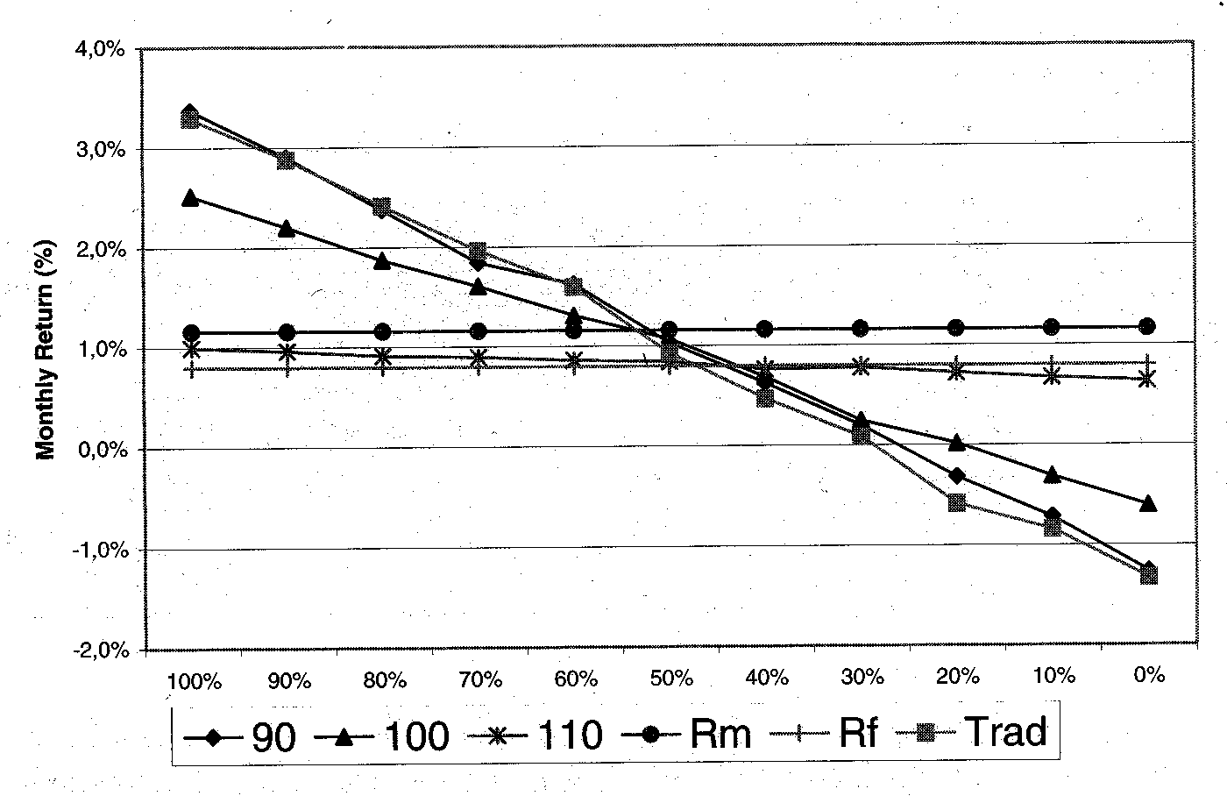
Figure 7: Expected returns for different accuracy levels and different strategies
The deep in-the-money call (90) can be seen to approximate the traditional timing returns for all accuracy levels. The at-the-money call (100) reflects lower upside and lower downside results, and the out-the-money call (110) is almost equivalent to a buy-and-hold approach. Whilst the relationship between return and timing accuracy is intuitive, the risk return relationship is less so. These results are shown in Table 7 and Figure 8:

Table 7: Risk levels for different market timing strategies
Risk Bet
Accuracy | Call Strike Prices |  |  |  |  | Market | Risk Free | Traditional
Level | 90 | 95 | 100 | 105 | 110 | Rm | Rf | Timing
100% | 0,0% | 0,0% | 0,0% | 0,0% | 0,0% | 2,1% | 0,0% | 0,0%
90% | 0,2% | 0,2% | 0,1% | 0,1% | 0,0% | 2,1% | 0,0% | 0,1%
80% | 0,4% | 0,4% | 0,3% | 0,1% | 0,0% | 2,1% | 0,0% | 0,4%
70% | 0,8% | 0,5% | 0,4% | 0,2% | 0,0% | 2,1% | 0,0% | 0,6%
60% | 0,8% | 0,8% | 0,5% | 0,3% | 0,1% | 2,1% | 0,0% | 0,8%
50% | 1,1% | 0,9% | 0,7% | 0,3% | 0,1% | 2,1% | 0,0% | 1,1%
40% | 1,3% | 1,2% | 0,8% | 0,4% | 0,1% | 2,1% | 0,0% | 1,3%
30% | 1,4% | 1,4% | 1,0% | 0,5% | 0,1% | 2,1% | 0,0% | 1,5%
20% | 1,7% | 1,6% | 1,2% | 0,5% | 0,1% | 2,1% | 0,0% | 1,7%
10% | 1,8% | 1,7% | 1,3% | 0,6% | 0,1% | 2,1% | 0,0% | 1,9%
0% | 2,1% | 1,9% | 1,4% | 0,6% | 0,2% | 2,1% | 0,0% | 2,1%

Figure 8 shows that market timing is worthwhile. The level of downside risk is considerably reduced for all timing strategies. Whilst the expected monthly return is clearly dependent upon the timing accuracy, even a 50% accuracy level will achieve the same return as a “buy and hold the market” approach, but with only half the downside risk. Waksman et al (1997) produced similar results.
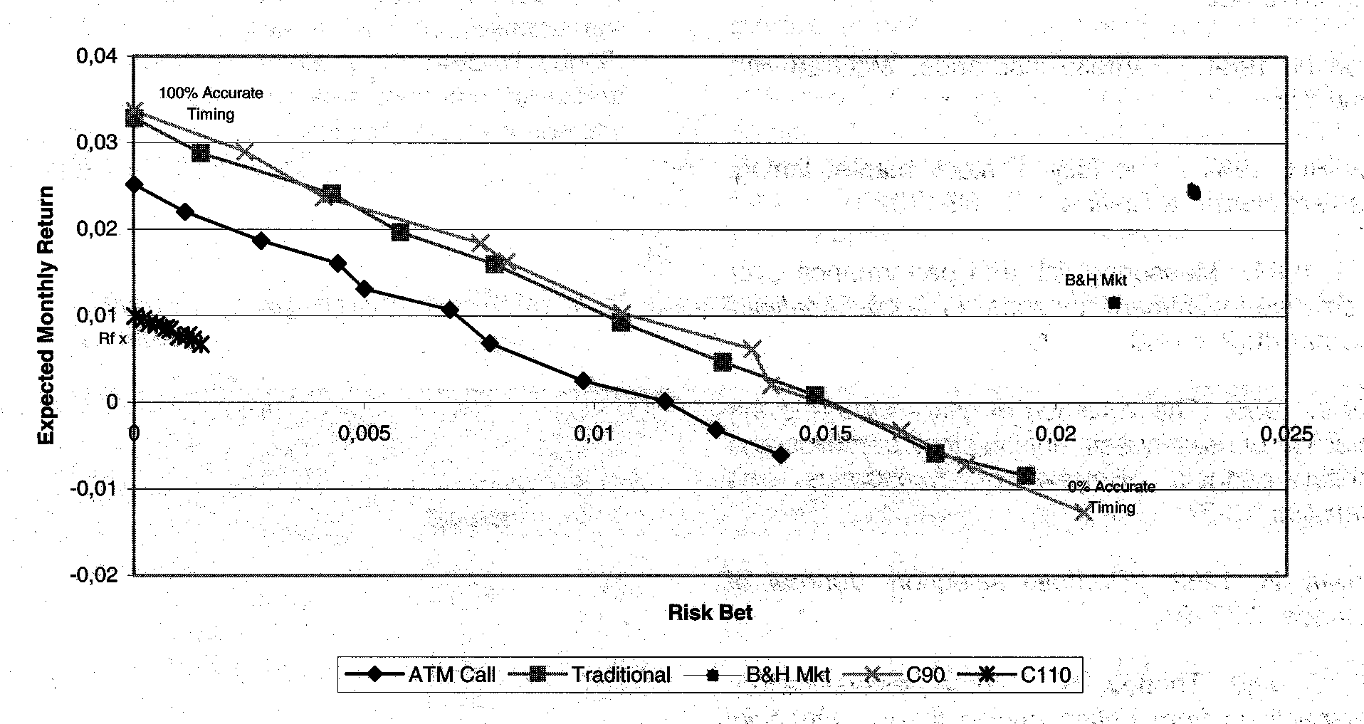
Figure 8: Risk/return relationships for different timing strategies

⁵Put-call parity ensures that an equivalent scenario would be to hold the Market with a put option on the Market – “Portfolio Insurance” (Hansen (1984)).
⁶Option prices were calculated using the Black and Scholes option pricing formula for European options. Where options were purchased it was assumed that the cost of the option was deducted from the initial investment capital. Where options were written the premium was added to the initial investment.
⁷For annual review periods: $P_{t } = P_{0}e^{((\text{Rf}−0\text{.}5σ^{2}) + σ\text{\sim }N(0,1))}$
This assumes a log-normal distribution of prices.
⁸Several other researchers have examined the problem of asymmetric risk, particularly Sortino (1996). The Sortino ratio, a variation of the above, is commonly used to measure downside portfolio risk.
⁹“bet” is simply used for convenience, being the Hebrew equivalent of the Greek beta.

4. CONCLUSION
This paper combines insights from the CAPM with market timing and option pricing theory for short review periods. The use of an asymmetric approach to measure risk, coupled with the benefits of a dynamic market, are suited to the use of an options pricing framework. The paper suggests the use of an asymmetric measure of systematic risk (bet) in place of beta and illustrates the risk reward payoffs for various positions in an asymmetric risk pricing model. A linear relationship between downside risk (bet) and return is found for both conventional strategies and options based approaches. It is shown that the use of options yields equivalent risk related returns. The study confirms the finding of other researchers that, for short review periods, market timing significantly reduces downside risk, and, for reasonable levels of accuracy, enhances expected returns. An empirical analysis is required to triangulate these findings. Further work is needed to measure downside risk (instead of beta) for individual securities. Additional research is also required to estimate the implied forward market premium from futures prices of options on the market index.

REFERENCES
Bodie Z, Kane A and Marcus A. 1996. Investments. Irwin, Boston, 231-233.
Butler K and Domian DL. 1991. Risk, diversification, and the investment horizon. Journal of Portfolio Management, Spring, 17(3):41-48.
Firer C. 1993. Estimating the return parameters for the CAPM. De Ratione, 7(1):23-29.
Firer C, Sandler M and Ward M. 1992. Market timing revisited. Investment Analyst Journal, 35:7-13.
Firer C, Sandler M and Ward M. 1992. Market timing: A worthwhile strategy? Omega, International Journal of Management Science, 20(3):313-322.
Hanson H. 1984. Portfolio insurance, McGraw-Hill, New York.
Jeffrey RH. 1984. The folly of stock market timing. Harvard Business Review, 62, 102-110.
Levy H. 1984. Measuring risk and performance over alternative investment horizons. Financial Analysts’ Journal, 40(2):61-68.
Lintner J. 1965. The valuation of risk assets and the selection of risky investments in stock portfolios and capital budgets, Review of Economics and Statistics, 13-37.
Markowitz H. 1952. Portfolio selection. Journal of Finance, 7:77–91.
Merrill C and Thorley S. Time diversification: Perspectives from option pricing theory, Financial Analysts Journal, May/June, 13-19.
Sandler M. 1989. Risks and returns associated with market timing. Unpublished MBA research report, Johannesburg; University of the Witwatersrand.
Sharpe WF. 1964. A simplified model for portfolio analysis, Management Science, 9:277-293.
Sortino FA. 1994. Performance measurement in a downside risk framework. The Journal of Investing, Fall.
Waksman G, Sandler M, Ward M and Firer C. 1997. Market timing on the JSE using derivative instruments. Omega, International Journal of Management Science, 25(1):81-91.
Winston WL. 1996. Simulation modeling using @risk, Wadsworth, California.

See later discussion on the distribution of the risk free return.
Conventional macro-economic policy requires central banks to lower their (short-term) lending rates when the yield curve is high to stimulate the economy and vice-versa to slow down growth when long-term rates are low. Consequently, the expected market premium would be high as short-term interest rates are reduced in anticipation of an expansionary market and vice-versa.

